

BREAKFAST MENU
Available 8.00 – 8.30am
Bacon & Egg/Sausage & Egg Muffin | $4.50
Hash Brown | $1.00
Ham & Cheese Croissant | $4.50
Ham & Cheese Toastie | $4.50
Up & Go 250ml  Hot Chocolate | $2.50  $3.00
Coffee | $3.50
 | 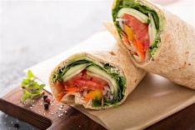
SANDWICHES, WRAPS & SALADS
WRAPS
Chicken Caesar | $7.00
Chicken, Mayo & Salad | $7.00
Flame Grilled Chicken & Salad | $7.00
Ham, Mayo & Salad | $7.00
SANDWICHES
Egg & Lettuce | $4.50
Chicken, Lettuce & Mayo | $4.50
Ham, Cheese & Tomato | $4.50
Salad | $4.50
Roast Beef, Cheese & Pickle | $4.50
SALADS
Chicken Caesar | $7.00
Flame Grilled Chicken | $7.00
Garden Salad with Chicken or Ham | $7.00
CANTEEN MENU
2025

HOT FOOD
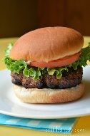  Chicken Burger |  |  | $6.00
Cheese Burger |  |  | $6.00
Beef & Bacon Burger |  |  | $6.00
Garlic Bread |  |  | $3.00
Pork Riblet Roll |  |  | $5.00
Meatball Sub |  |  | $5.00
Cheese Toastie |  |  | $3.50
Ham & Cheese Toastie |  |  | $4.50
Chicken, Cheese & BBQ Sauce Toastie |  |  | $4.50
Chicken Chips (5) |  |  | $4.00
Traveller Pie Plain/Cheese & Bacon |  |  | $4.50
Sausage Roll - King Size |  |  | $4.50
Chicken Tender Wrap Chilli or Plain |  |  | $5.00
Chicken Teriyaki & Rice |  |  | $7.00
Chicken karaage & Rice |  |  | $7.00
Beef Lasagne (GF) Pre-order only |  |  | $5.50
SNACKS
Watermelon |  |  | $3.00
Loaded Cookie |  |  | $1.50
Chocolate Brownie |  |  | $2.00
Greek Yogurt & Topping |  |  | $3.00
Pringles Sour Cream & Chives |  |  | $1.50
Piranha Snaps |  |  | $2.00
Red Rock Deli Chips |  |  | $2.00
Popcorn (GF) |  |  | $1.50
Banana Bread |  |  | $2.50
Snack Pack |  |  | $3.50
Mousse |  |  | $2.00

Online Orders can be made at Flexischools.com.au before 8.45am or at the canteen before school.

 | DRINKS
 | Breaka Flav Milk 300ml | $3.50
 | Breaka Flav Milk 500ml | $4.50
 | Ice Break 500ml | $5.00
 | Oak Plus 500ml  Oak Carton 500ml | $5.00  $5.00
 | Juice Popper | $2.00
 | Orchy Juice 350ml | $4.00
 | Glee 250ml | $3.00
 | 600ml Water | $2.00
 | 1 Litre Water Pop Top | $3.00
 | Waterfords 475ml | $3.50
 | Up & Go 250ml | $2.50
 | 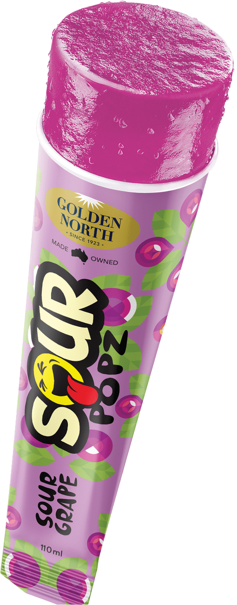
 | ICE CREAMS
 | Zooper Dooper | $1.00
 | Frozen Yogurt | $3.00
 | Frosty Fruit - Tropical | $3.00
 | Icy Pole | $2.00
 | Milo Scoop Shake | $4.00
 | Lifesaver | $3.00
 | Ice Cream Cup (Choc, Vanilla) | $2.00
 | Sour Pop | $2.50
 | Swing Milky | $2.50
 | Open 8am – 1.45pm
 | Ph 380402343
 | Eftpos and Cash Accepted

